**Assignment No: 06**

**Favorite Colors:**

* Red
* Purple
* Black
* Pink
* Orange

**Color Meanings:**

**Red:**

Red evokes a passionate and magical response. It is a color that increases your heart rate, makes your breath faster, and is generally associated with energy, excitement, and passion. It’s one of the colors that is attention-grabbing, while it can also be provocative and excitable.

**Purple:**

Purple color historically represents the robes of kings and queens. It is the most royal color that is associated with wealth, prosperity, rich sophistication. Purple color induces an attitude of problem solving. However an increased use of purple gives an effect of being artificial. Purple has also been selected as a favorite color by young teenage girls.

**Black:**

Black is another popular color option for brands and it tends to be one of the most classic options. It’s both classic and sophisticated and it can make a brand identity stand out. It seems to work perfectly with luxury products, blending the classic and powerful elements. Black is one of the colors that can be combined with others to add a stronger emotion, without losing the classical appeal. It is the color for timelessness, sophistication and power.

**Pink:**

Pink is a combination of red and white, both colors add a little to its characteristics. Pink helps people get in touch with their thoughtful and caring side, either through the need to receive feelings. It gets action from the red color, and the white color gives it an opportunity to achieve success and insight. The deeper the pink color, the more passion and energy it radiates.

**Orange:**

Orange is the flashiest color on earth. Orange color represents fun times, happy and energetic days, warmth and organic products. It is also associated with ambition. This color in no way induces calmness but more toward excitement and energy. Orange is also seen a color of change.

**Popular Brands:**

**KitKat:** 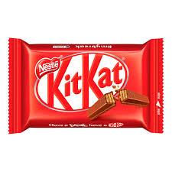

KitKat is famous for its yummy taste. It is very easy to purchase KitKat, can be found in every supermarket. All of its packaging is red because red color is used to draw attention. It has an intense nature of drawing the eye toward it. Red is also linked to energy and excitement. The color and packaging shows a good quality product energy and dynamism. KitKat means coolness, break (relief) from whatever, tasty, easy to share and fun.

**Kadus Hair color:** 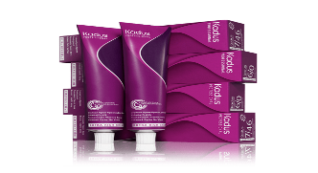

Kadus Standing Professional Color is a cream for permanent hair coloring. Kadus Perm Color works extra gray coverage.Its packaging color is purple because purple is a sophisticated yet mysterious color. It tends to be used with higher-end products due to its association with royalty and elegance. Purple’s mysterious element is also linked with spirituality, and it can bring a magical element to your branding.

**Adidas Bags:** 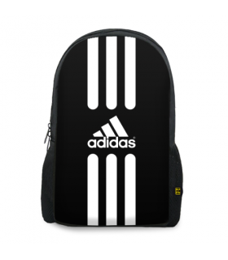

Adidas have huge range of good bags due to its comfort and popularity. It is one of the most famous brand in Pakistan. Adidas have large range of black color bags the reason behind this is that black color depicts the feeling of power strength and authority. Black color is also linked with intelligence. Black color is also referred for darkness or evil. Therefore black is considered as a serious color and too much of black is also considered unpleasant.

**LG AC: **

LG inverter split ACS - stylishly innovative Air Conditioners for best cooling experience.They give you the power to maintain the ideal temperature all year long.Most of its Ac’s color is pink because pink is a sign of hope. It is a positive color that inspires warm and comforting feelings. The color pink gives the feeling that everything will go well or be okay. Most people have heard of the saying “everything is rosy”. It may also indicate good health and success.

**Tang:** 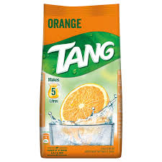

Tang orange canister, is a refreshing way to rejuvenate your electrolytes and get extra energy after your workout or anytime you need recharging. Its packaging color is orange because orange makes an ideal color choice for brands that want to blend the optimism and the brightness of yellow and the passion and the energy of red. It is a creative and cheerful color that evokes a friendly and adventurous feeling.